# Department of Computer Technology

### Vision of the Department

*To be a well-known centre for pursuing computer education through innovative pedagogy, value-based education and industry collaboration.*

### Mission of the Department

*To establish learning ambience for ushering in computer engineering professionals in core and multidisciplinary area by developing Problem- solving skills through emerging technologies****.***

## Session 2025-2026

**Mission:** To Make real life project related to computer vision

**Vision:** To Become Excellent in Computer vision

**Program Educational Objectives of the program (PEO):** (broad statements that describe the professional and career accomplishments)

|  |  |  |  |
| --- | --- | --- | --- |
| PEO1 | **Preparation** | **P: Preparation** | **Pep-CL abbreviation**  **pronounce as Pep-si-lL easy to recall** |
| PEO2 | **Core Competence** | **E: Environment (Learning Environment)** |
| PEO3 | **Breadth** | **P: Professionalism** |
| PEO4 | **Professionalism** | **C: Core Competence** |
| PEO5 | **Learning**  **Environment** | **L: Breadth (Learning in diverse areas)** |

**Program Outcomes (PO):** (statements that describe what a student should be able to do and know by the end of a program)

## Keywords of POs:

Engineering knowledge, Problem analysis, Design/development of solutions, Conduct Investigations of Complex Problems, Engineering Tool Usage, The Engineer and The World, Ethics, Individual and Collaborative Team work, Communication, Project Management and Finance, Life-Long Learning

**PSO Keywords:** Cutting edge technologies, Research

“I am an engineer, and I know how to apply engineering knowledge to investigate, analyse and design solutions to complex problems using tools for entire world following all ethics in a collaborative way with proper management skills throughout my life.” *to contribute to the development of cutting-edge technologies and Research*.

**Integrity:** I will adhere to the Laboratory Code of Conduct and ethics in its entirety.

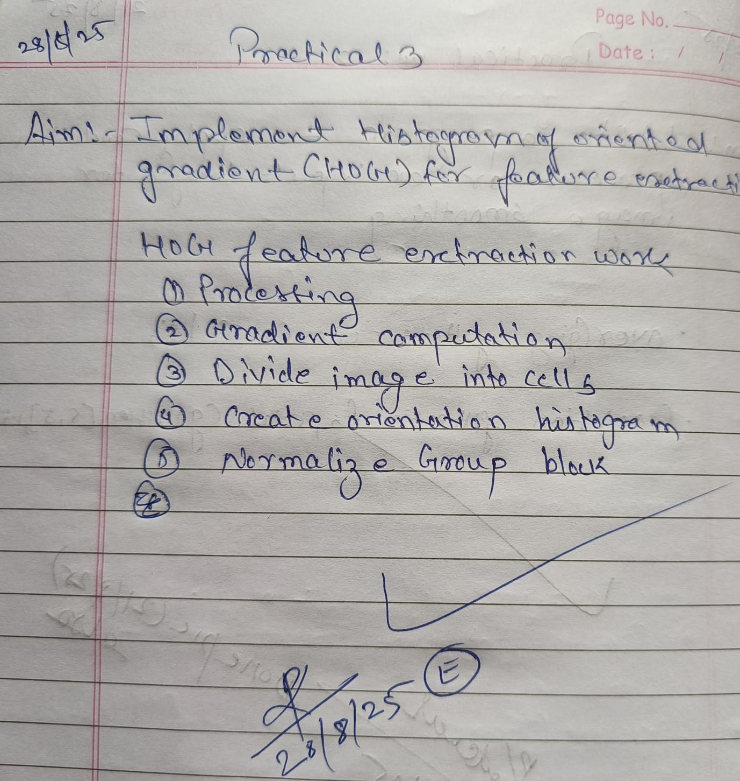

**Ganesh Pandile**

## Name and Signature of Student and Date

(Signature and Date in Handwritten)

# Department of Computer Technology

### Vision of the Department

*To be a well-known centre for pursuing computer education through innovative pedagogy, value-based education and industry collaboration.*

### Mission of the Department

*To establish learning ambience for ushering in computer engineering professionals in core and multidisciplinary area by developing Problem- solving skills through emerging technologies****.***

|  |  |  |  |
| --- | --- | --- | --- |
| **Session** | **2024-25 (ODD)** | **Course Name** | **Computer vision Lab** |
| **Semester** | **5** | **Course Code** | **CT** |
| **Roll No** | **46** | **Name of Student** | **Ganesh Pandile** |

|  |  |
| --- | --- |
| **Practical Number** | 3 |
| **Course Outcome** | Extract meaningful features from images using descriptors such as HOG and SIFT. |
| **Aim** | Implement Histogram of Oriented Gradient (HOG) for Feature extraction. |
| **Problem Definition** |  |
| **Theory**  **(100 words)** | HOG (Histogram of oriented Gradients) is a feature extraction technique in computer vision that captures object shape and structure by computing gradient orientations in localized regions of an image. It divides the image into small cells, computers gradient direction histograms in each cell, and normalizes them over blocks to form a robust feature vector used for tasks like object detection. |
| **Procedure and Execution**  **(100 Words)** | Algorithm:  **1)** **Read Image :**   * Load an image from a specified file path.   **2)** **Convert to Grayscale (if needed) :**   * Check if the image has 3 color channels (i.e., it's an RGB image).   + If **yes**, convert it to a grayscale image using rgb2gray().   + If **no**, the image is already grayscale; use it as is.   **3)** **Extract HOG Features :**   * Use the extractHOGFeatures() function to extract Histogram of Oriented Gradients from the grayscale image. * Parameters:   + CellSize = [8 8] → each cell is 8×8 pixels.   + NumBins = 9 → 9 orientation bins. * Returns:   + hogFeatures: the feature vector (a 1D array of HOG descriptors).   + hogVisualization: an object for visualizing HOG features.   **4)** **Display Original and HOG Images :**   * Create a figure window with two subplots. * In the first subplot:   + Show the original image.   + Title: 'Original Image' * In the second subplot:   + Show the same original image.   + Overlay the HOG feature visualization using plot(hogVisualization).   + Title: 'HOG Features Visualization'   **5)** **Print HOG Feature Size :**   * Output the size (length) of the HOG feature vector using fprintf. |
| Code:  img = imread("C:\Users\student\Desktop\CT_46_CV\deer.jpg");  if size(img, 3) == 3  grayImg = rgb2gray(img);  else  grayImg = img;  end  [hogFeatures, hogVisualization] = extractHOGFeatures(grayImg, 'CellSize', [8 8], 'NumBins', 9);  figure;  subplot(1, 2, 1);  imshow(img);  title('Original Image');  subplot(1, 2, 2);  imshow(img);  hold on;  plot(hogVisualization);  title('HOG Features Visualization');  fprintf('Size of HOG feature vector: %d\n', numel(hogFeatures)); |
| Output: |
| **Output Analysis** | * Two images shown:   + Original.   + HOG visualized. * Console output:   + Number of features .   Used for shape/edge-based feature extraction in tasks like object detection. |
| **Link of student Github profile where lab assignment has been uploaded** |  |
| **Conclusion** | Successfully Implemented Histogram of Oriented Gradient (HOG) for Feature extraction. |
| **Plag Report (Similarity index < 12%)** |  |
| **Date** | **31/08/2025** |

# Department of Computer Technology

### Vision of the Department

*To be a well-known centre for pursuing computer education through innovative pedagogy, value-based education and industry collaboration.*

### Mission of the Department

*To establish learning ambience for ushering in computer engineering professionals in core and multidisciplinary area by developing Problem- solving skills through emerging technologies****.***

|  |  |
| --- | --- |
|  |  |
| Conclusion | Successfully Implemented Histogram of Oriented Gradient (HOG) for Feature extraction. |
| Plag Report (Similarity index < 12%) |  |
| Date | 31/08/2025 |